COURSE CCPS 510
DATABASE SYSTEMS (DBMS) I
ASSIGMENT-I (Version1)
Rui Zhnag 500736315

INSTRUCTOR: | Ersan Cam
INSTRUCTOR E-MAIL: | ersan.cam@torontomu.ca

Please place all your answers and screen shots of your results into this document. Once you finish working on this file, please email me.

This Assignment has different parts each represent different Labs (Ideal time to solve these are in dedicated Lab times of the course)

Lab Section- A:

Task1)
Suppose you are working within the framework of the conceptual model in Figure 1 below.

Figure 1 The Conceptual Model Car Maintenance Services
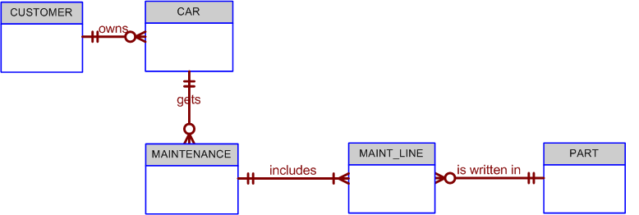

Given the conceptual model in Figure 1:

  - Write the business rules that are reflected in it.

Even a simple ERD such as the one shown in Figure Q4.5 is based on many business rules. Make sure that each business rule is written on a separate line and that all of its details are spelled out. In this case, the business rules are derived from the ERD in a “reverse-engineering” procedure designed to document the database design. In a real world database design situation, the ERD is generated on the basis of business rules that are written before the first entity box is drawn. (Remember that the business rules are derived from a carefully and precisely written description of operations.)

Here are business rules:
1. A customer owns zero or many cars.
One car must belong to one customer.
2. Car gets zero or many maintenances.
Maintenance must apply for only one car.
3. Maintenance includes one or many MAINT_LINES.
One Maint_line must included in one maintenance.
4. A maint-line must be written in one part.
One Part can be written in zero or many maint-lines.
5.
6.

Task 2)
Below questions is based on the ERD in Figure 2.
FIGURE 2 - The ERD of
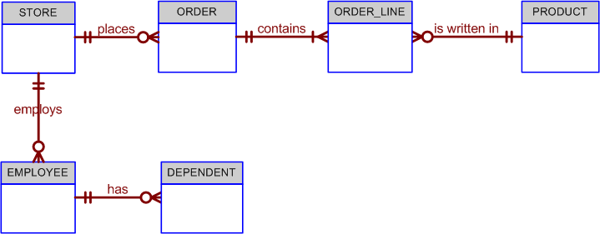

2-a)
Fill Cardinalities. I have left 2 of them on the diagram for you as hint. You can fill rest of 8
The Cardinalities
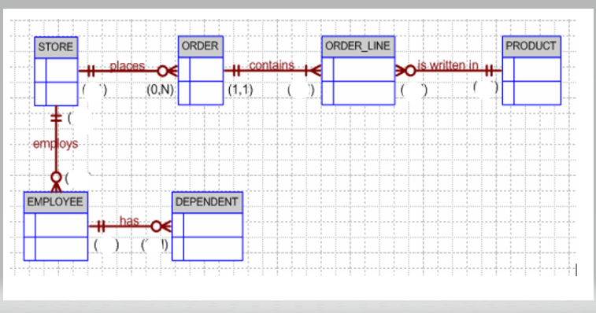

P.S: You can print and write on the paper and take picture and paste here or take this above picture as screen shot and edit on it or use draw.io free cloud tool to complete ERD diagrams.
2-b ) Write at least 6 Business Rules by analyzing ERD diagram above
- A store places zero or many orders.
- Order must be placed in one store.
- Each order contains one or many order_lines.
- Each order_line must be contained in one order.
- One order_line must be written in one product.
- One product has zero or many order_line.
- One store employs zero or many employees.
- One employed must be employed in one store.
- One employee can have zero or many dependents.
- One dependent must belong to one employee.

Normalization

3)
Given the structure shown in Table P3.1, write the relational schema and draw its dependency diagram. Label all transitive and/or partial dependencies.

The dependency diagram is shown in Figure P3.1a. Note that the order of the attributes has been changed to make the transitive dependencies easier to mark. (In any case, the order in which the attributes are written into a relational database table is immaterial.) The relational schema is written below Figure P6.6a.

Figure P3.1a The Dependency Diagram for Problem 3
The relational schema is written as:

EMPLOYEE(EMP_CODE, EMP_LNAME, EMP_EDUCATION, JOB_CLASS,
EMP_DEPENDENTS,DEPT_CODE, DEPT_NAME, DEPT_MANAGER,
EMP_TITLE, EMP_DOB, EMP_HIRE_DATE, EMP_TRAINING,
EMP_BASE_SALARY, EMP_COMMISSION_RATE)

b. If we draw the dependency diagrams that are in 3NF.

Dependency diagrams have no way to indicate multi-valued attributes, nor do they provide the means through which such attributes can be handled. Therefore, the solution to this problem requires a basic knowledge of modeling concepts, once again indicating that normalization and design are part of the same process. Given the sample data shown in Problem 6, EDUCATION, DEPENDENT and QUALIFICATION are multi-valued attributes whose values are stored as strings. We have created the appropriate entities to avoid the use of multi-valued attributes. (See Figure P6.6b.)

Figure P3.1b The Dependency Diagrams for Problem in b

The relational schemas are written as:
Please mark Primary Key for each table with Bold and Underline (Sample hint is given to you for DEPARTMENT table

EMPLOYEE(EMP_CODE, EMP_LNAME, DEPT_CODE, JOB_CLASS, EMP_DOB,
EMP_HIREDATE)

DEPENDENT(EMP_CODE, DEP_NUM, DEP_FNAME, DEP_TYPE)

DEPARTMENT(DEPT_CODE, DEPT_NAME, EMP_CODE)

JOB(JOB_CLASS, JOB_TITLE, JOB_BASE_SALARY)

EDUCATION(EDUC_CODE, EDUC_DESCRIPTION)

QUALIFICATION(EMP_CODE, EDUC_CODE, QUAL_DATE_EARNED)

c. Draw the relational diagram (ERD with Chen or Crows foot).

Draw ERD diagram with www.draw.io or visio or draft on paper with pencil and take picture and paste here.

This following section (Lab B) is for Physical Database Design practices to build database tables and add constraints to apply business rules by using DDL (Data Definition Language ) of SQL.
Lab Section- B: DDL (Data Definition Commands) to create physical Database
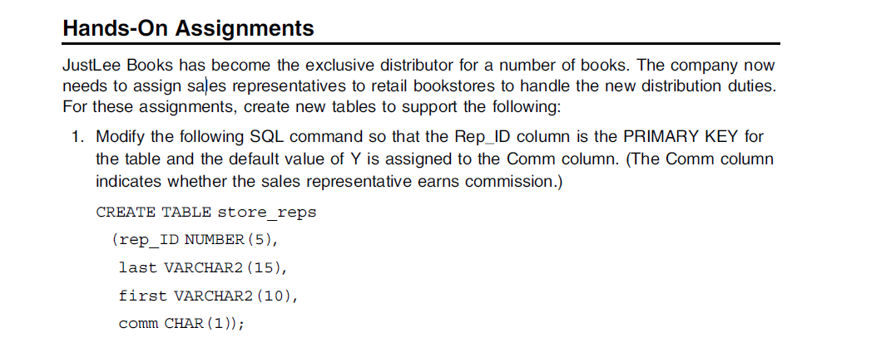
CREATE TABLE STORE_REPS
(
rep_ID NUMBER(5),
last VARCHAR2(15),
first VARCHAR2(10),
comm CHAR(1) DEFAULT 'Y',
CONSTRAINT store_reps_pk PRIMARY KEY (rep_ID)
);

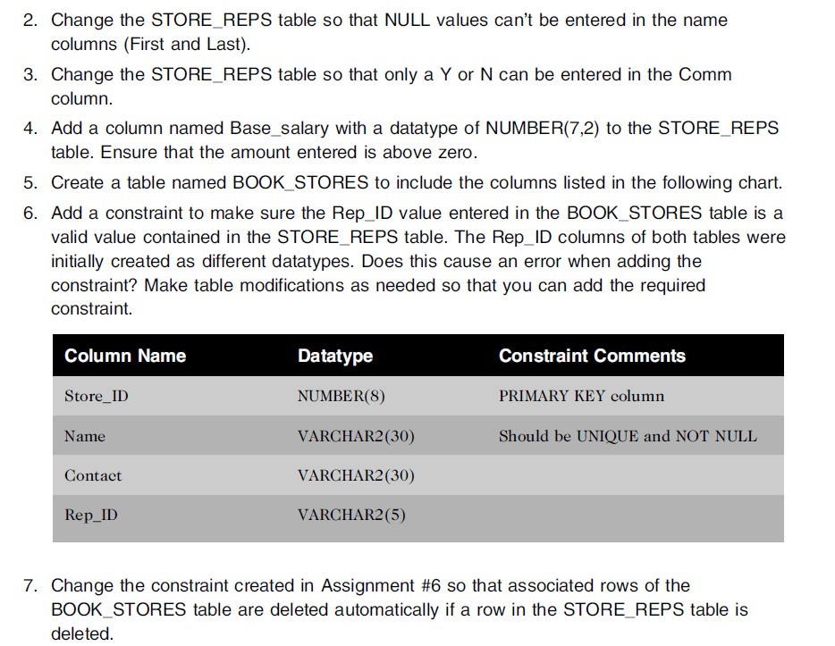
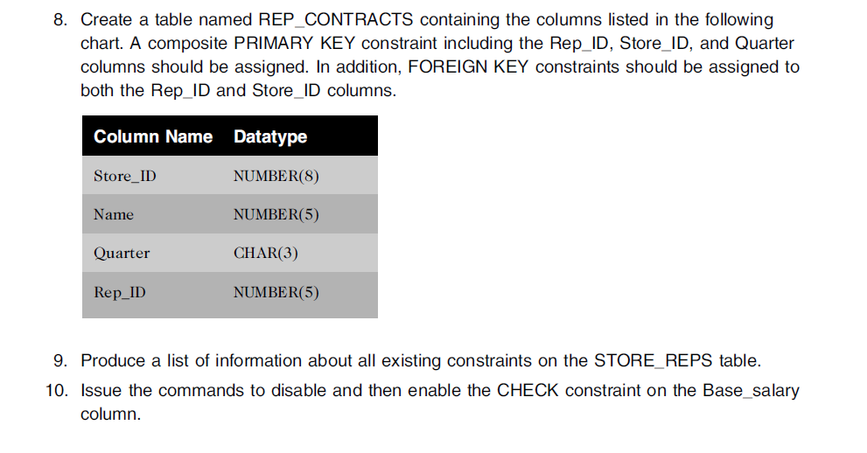
2.
ALTER TABLE STORE_REPS
MODIFY (last NOT NULL, first NOT NULL);
3.
ALTER TABLE STORE_REPS
ADD CONSTRAINT comm_chk CHECK (comm IN ('Y', 'N'));
4.
5.
CREATE TABLE BOOK_STORES
(
Store_ID NUMBER(8),
Name VARCHAR2(30) UNIQUE NOT NULL,
CONTACT VARCHAR2(30),
Rep_ID VARCHAR2(5),
CONSTRAINT book_stores_pk PRIMARY KEY (Store_ID)
);

6. Yes, the different types in Rep_ID in the BOOK_STORES table and rep_ID in the table store_reps cause an error when adding constraint. (column type incompatible with referenced column type).
ALTER TABLE BOOK_STORES
MODIFY Rep_ID NUMBER(5);
ALTER TABLE BOOK_STORES
ADD CONSTRAINT book_stores_store_reps_fk FOREIGN KEY (Rep_ID) REFERENCES store_reps(rep_ID);
7.
ALTER TABLE BOOK_STORES
DROP CONSTRAINT book_stores_store_reps_fk;
ALTER TABLE BOOK_STORES
ADD CONSTRAINT book_stores_store_reps_fk FOREIGN KEY (Rep_ID) REFERENCES store_reps(rep_ID) ON DELETE CASCADE;
8.
ALTER TABLE BOOK_STORES
ADD CONSTRAINT book_stores_store_id_rep_id_uk UNIQUE (Store_ID, Rep_ID);
CREATE TABLE REP_CONTRACTS
(
Store_ID NUMBER(8),
Name NUMBER(5),
Quarter CHAR(3),
Rep_ID NUMBER(5),
CONSTRAINT rep_contracts_pk PRIMARY KEY (Store_ID, Quarter, Rep_ID),
CONSTRAINT rep_contracts_book_stores_fk FOREIGN KEY (Store_ID, Rep_ID) REFERENCES BOOK_STORES(Store_ID, Rep_ID)
);
9.
SELECT * FROM USER_CONSTRAINTS WHERE TABLE_NAME = 'STORE_REPS';
10.
ALTER TABLE STORE_REPS
MODIFY CONSTRAINT base_salary_chk DISABLE;
ALTER TABLE STORE_REPS
MODIFY CONSTRAINT base_salary_chk ENABLE;
11. Create below 3 tables from ERD diagram for HR department.. Make sure using NUMBER in Oracle instead of INTEGER or DECIMAL
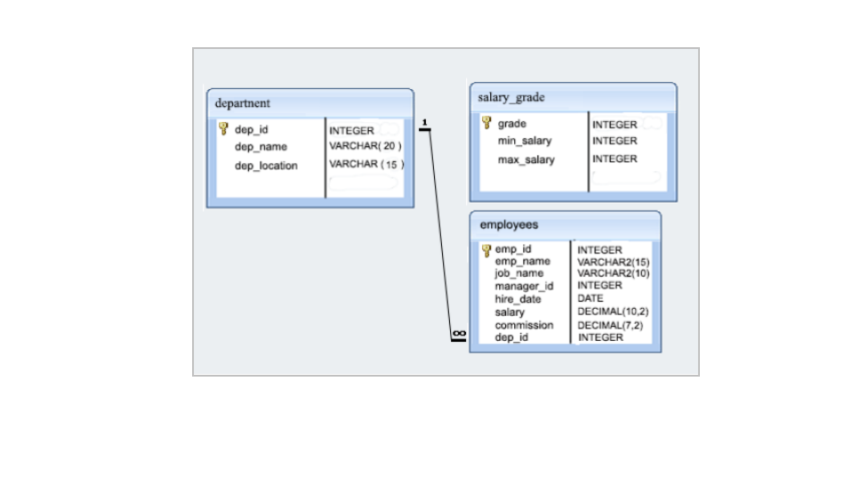
CREATE TABLE DEPARTMENT
(
dept_id NUMBER,
dept_name VARCHAR2(20),
dept_location VARCHAR2(15),
CONSTRAINT department_pk PRIMARY KEY (dept_id)
);
CREATE TABLE SALARY_GRADE
(
grade NUMBER,
min_salary NUMBER,
max_salary NUMBER,
CONSTRAINT salary_grades_pk PRIMARY KEY (grade)
);
CREATE TABLE EMPLOYEES
(
emp_id NUMBER,
emp_name VARCHAR2(15),
job_name VARCHAR2(10),
manager_id NUMBER,
hire_date DATE,
salary NUMBER(10,2),
commission NUMBER(7,2),
dep_id NUMBER,
CONSTRAINT employees_pk PRIMARY KEY (emp_id),
CONSTRAINT employees_department_fk FOREIGN KEY (dep_id) REFERENCES DEPARTMENT(dept_id)
);

This following section (Lab C) is for practice SELECT command to query data.

Lab Section - C) SELECT queries

Develop SQL code for below questions.

1- (Please Use Dream Home Database sample Data set)

- Find sum(total) salary in each branch and total number of staff working in each branch
SELECT SUM(SALARY), COUNT(*)
FROM DH_STAFF JOIN DH_BRANCH ON DH_STAFF.BRANCHNO = DH_BRANCH.BRANCHNO
GROUP BY DH_BRANCH.BRANCHNO;

- Provide a report for all of employees( staff) whose salary is greater than the Dream Home company’s average salary
SELECT *
FROM DH_STAFF
WHERE SALARY > (SELECT AVG(SALARY) FROM DH_STAFF);

- For each Branch office , list the staff numbers and names of staff who manage properties and the properties that they manage
Hint: Join Staff and PropertyForRent
SELECT COUNT(*) AS NUM_OF_STAFF, FNAME, LNAME, DH_PROPERTYFORRENT.PROPERTYNO
FROM DH_STAFF JOIN DH_PROPERTYFORRENT ON DH_STAFF.STAFFNO = DH_PROPERTYFORRENT.STAFFNO
GROUP BY DH_PROPERTYFORRENT.BRANCHNO, DH_PROPERTYFORRENT.PROPERTYNO, FNAME, LNAME;
- Increase all assistant staff salary by %30 (UPDATE)
UPDATE DH_STAFF
SET SALARY = SALARY * 1.3
WHERE POSITION = 'Assistant';

- For staff name called Ann Beech , write an update command to promote her as Asst Manager and increase her salary to 8900 and also move her to same branch as John White (SL21)
UPDATE DH_STAFF
SET POSITION = 'Asst Manager', SALARY = 8900, BRANCHNO=
(SELECT BRANCHNO FROM DH_STAFF WHERE FNAME LIKE '%John%' AND LNAME LIKE '%White%')
WHERE FNAME LIKE '%Ann%' AND LNAME LIKE '%Beech%';
2- Use HumanResources Database for below questions

- Display department name, manager name, and city.
SELECT DEPARTMENT_NAME, FIRST_NAME || ' ' || LAST_NAME, CITY
FROM HR_DEPARTMENTS JOIN HR_EMPLOYEES ON HR_DEPARTMENTS.DEPARTMENT_ID = HR_EMPLOYEES.DEPARTMENT_ID
JOIN HR_LOCATIONS ON HR_DEPARTMENTS.LOCATION_ID = HR_LOCATIONS.LOCATION_ID;
- Display country name, city, and department name.

c.
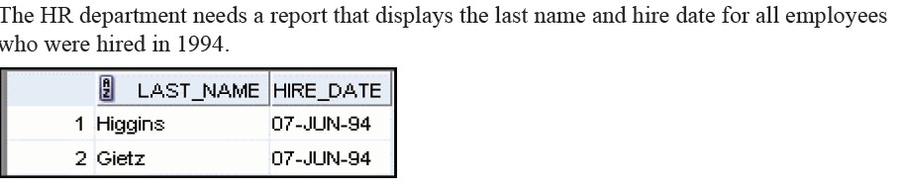
Hint : Use Like with % or TO_CHAR(Hire_Date,’YYYY’) = ‘1994’

Rubric for Lab Section A, B and C
